**Setting up the Roslyn Internet Portal on a Chromebook**

1. Locate the Google Play Store app along the bottom bar of the Chromebook and open it 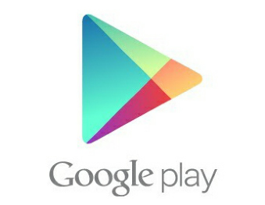
2. Once opened you will see the Microsoft Remote Desktop app, open it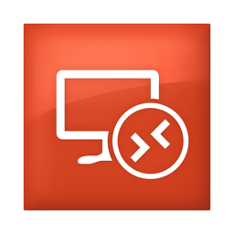
3. Choose Install to install the Microsoft Remote Desktop app 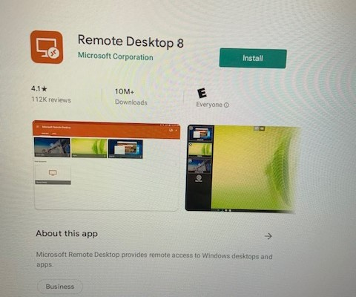
4. After it’s done installing, choose Open

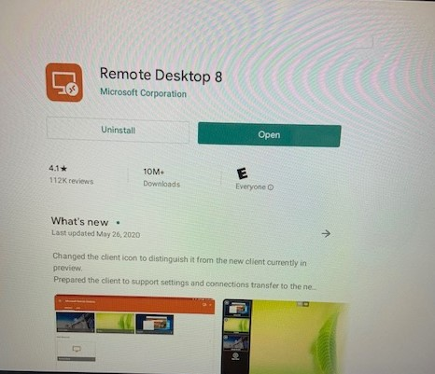

1. Click Accept

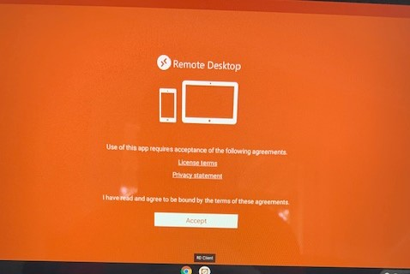

1. Choose the + sign from the top right, then choose ‘Remote Resource Feed’ 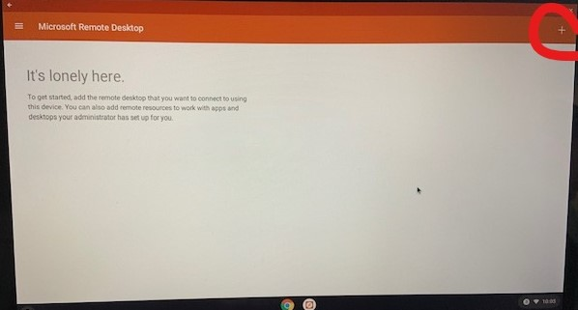
2. Type in: remoteapps.roslynschools.org and then click Next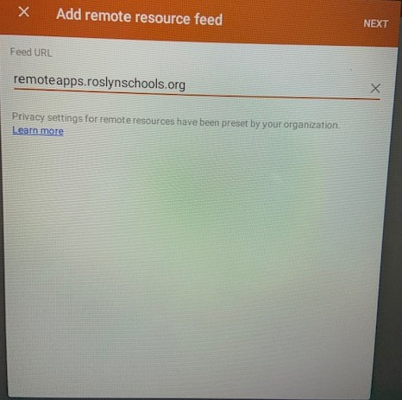
3. Click the field where it says Choose User Account and then choose Add user account 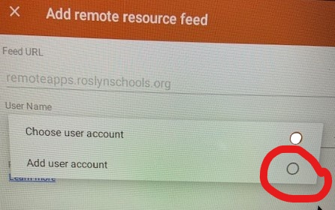
4. Enter in your Roslyn username in the format rosnet\username. For example for Brian Stein it would be rosnet\bstein (for students don’t forget your 2 digit year of graduation) and then enter in your Roslyn password, then click Save, then click Save again 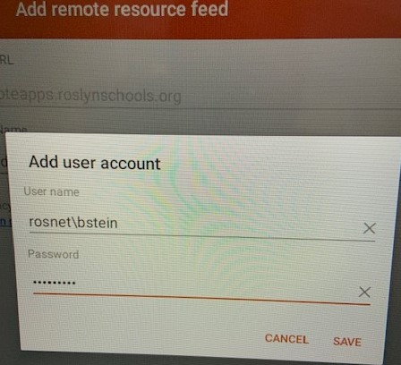
5. From the top, choose APPS to see all the available applications 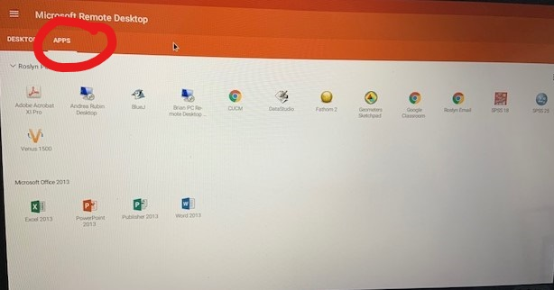
6. Click on the app you’d like to open, put a check in the box next to ‘Never ask again for connections to this PC,’ then click Connect 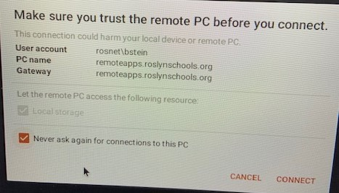
7. Click Allow 